Sierra Club’s Inner City Outings
Science Outdoors Curriculum

Written by Becky Niemiec, Sierra Club intern Fall 2011

ICO Science Outdoors- 3rd Grade
Author: Becky Niemiec

Location: The location of most of these outdoor field trips will be in Griffith Park, which is mainly dominated by a Coastal sage scrub community, one of the most threatened habitat types in the United States. The coastal sage scrub supports significant numbers of endemic species (found nowhere else). The scrub community consists of spiky yucca plants, cholla, and other rare native scrub that persists on sandy soils. Insect and reptile species, such as the Western Fence Lizard or the California Legless Lizard, are the most commonly seen and the most diverse. Griffith Park also contains Oak Woodland, which has one of the highest wildlife species richness of any habitat in California. The Oak trees provide acorns, which in turn provide food resources for many animals, such as the western gray squirrel and woodpeckers. Amphibians, such as the Coast Range newt, are also common in the area.

Science Standards: Below are specific science standards, taken directly from “Science Content Standards for California Public Schools,” that must be completed by the termination of 3rd grade. These are the specific standards that would apply directly to the outdoor project.
-students know plants and animals have structures that serve different functions in growth, survival, and reproduction.
-students know when the environment changes, some plants and animals survive and reproduce; others die or move to new locations
-students know that some kinds of organisms that once lived on Earth have completely disappeared and that some of those resembled others that are alive today.
-students must use numerical data in describing and comparing objects, events, and measurements.

Supplies: measuring tapes

Projects:
-Students will learn about endangered and extinct species, and then try and complete the “In Danger” Bingo game as they are hiking- they will cross off something when they see it.
-Then, students will spread out in a large area with oak trees (such as the area by the Merry Go Round parking lot) and be given measuring tapes and shown how to measure the circumference of a tree at breast height. They will then be asked to complete the “Tree Age Investigation” worksheet with a partner and will be asked which is the oldest and youngest trees that they found.

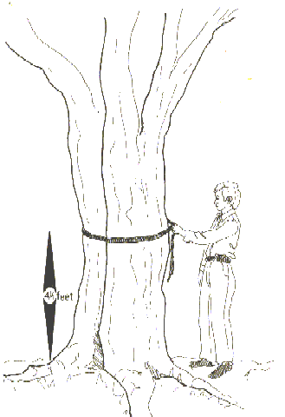
Tree Age Investigation

Trees can live for a very long time. In fact, some of the oldest trees are thousands of years old! We are going to compare different trees around us to see which one is the oldest.

The oldest trees will have the largest circumference. You will measure the circumference by wrapping the tape measure around the entire tree at your chest height. You may need your partners to help with this one!

First choose one species. Trees that look similar and have the same type of leaves will be of the same species. You will measure the circumference of three trees in the same species and record the circumference in the first table:

Table 1: Circumferences of Trees of the first Species
Describe the tree bark and leaves.

Draw a picture of a leaf from this tree.

Tree Number | Circumference
1
2
3

Which tree was the biggest?

Then choose your next species. These trees should look different from the first ones that you measured. Record the circumference of two trees in this species.

Table 2: Circumferences of Trees of the second Species

Tree Number | Circumference
1.
2.
Do you think trees in species 2 were older or younger than species 1?
In Danger?

All plants and animals live in a specific environment that they prefer. However, when environments change, many species can become endangered because they can die off. If all the organisms in a species die, then the species becomes extinct.

First, circle the boxes that contain an endangered species and color in a box with an extinct species.
Next, on your hike, put an X through boxes with species that you observe in real life and see if you can get three in a row!
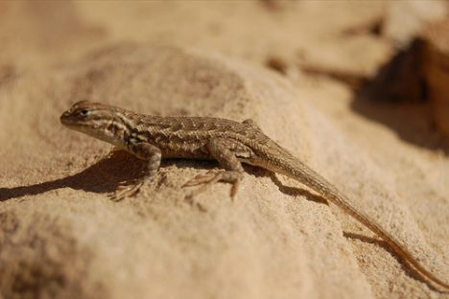
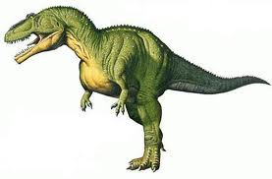
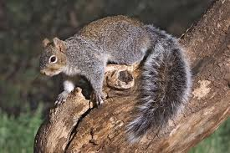
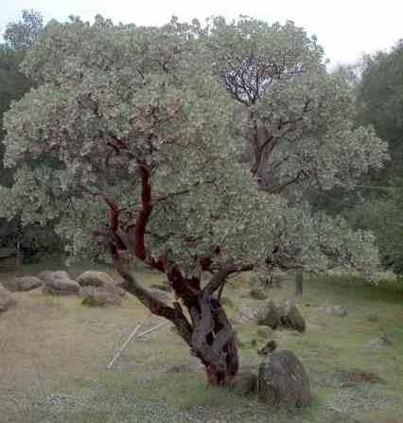  Bigberry Manzanita | Gray Squirrel | Dinosaur
Western Fence Lizard | 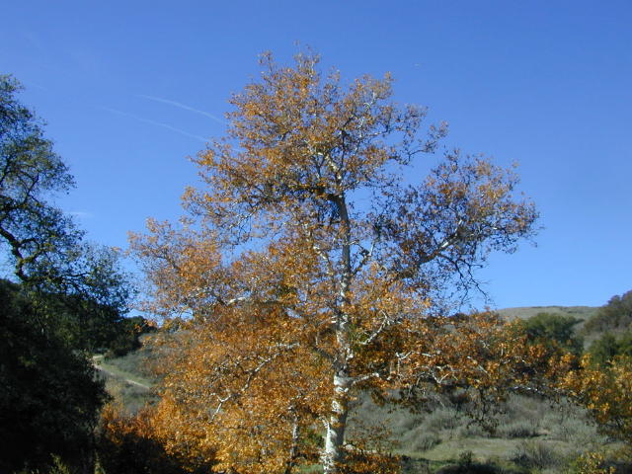  Western Sycamore | 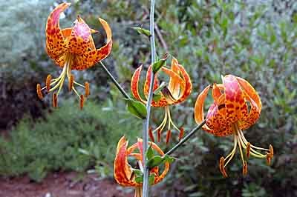  Humbolt Lily
Argentine Ant | Red-tailed Hawk | Coyote
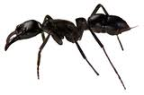
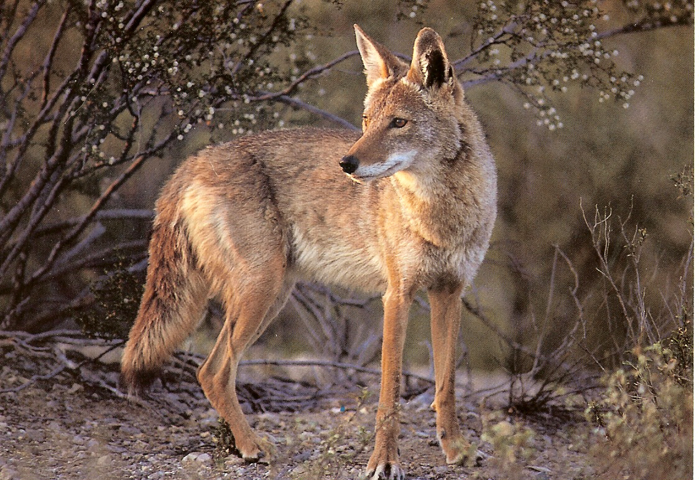
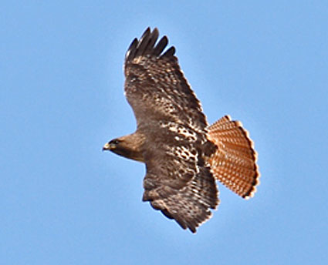
**Challenge Question: Which of these species is considered an invasive species?
ICO Science Outdoors- 4th Grade
Author: Becky Niemiec

Location:
The location of most of these outdoor field trips will be in Griffith Park, which is mainly dominated by a Coastal sage scrub community, one of the most threatened habitat types in the United States. The coastal sage scrub supports significant numbers of endemic species (found nowhere else). The scrub community consists of spiky yucca plants, cholla, and other rare native scrub that persists on sandy soils. Insect and reptile species, such as the Western Fence Lizard or the California Legless Lizard, are the most commonly seen and the most diverse. Griffith Park also contains Oak Woodland, which has one of the highest wildlife species richness of any habitat in California. The Oak trees provide acorns, which in turn provide food resources for many animals, such as the western gray squirrel and woodpeckers. Amphibians, such as the Coast Range newt, are also common in the area.

Science Standards: Below are specific science standards, taken directly from “Science Content Standards for California Public Schools,” that must be completed by the termination of 4th grade. These are the specific standards that would apply directly to the outdoor project.

Under Life Sciences:
-students know producers and consumers (herbivores, carnivores, omnivores, and decomposers) are related in food chains and food webs and may compete with each other for resources in an ecosystem.
-students know ecosystems can be characterized by their living (biotic) and nonliving (abiotic) components.
Under Earth Sciences:
-Students know the rock cycle (igneous, sedimentary, and metamorphic rocks)
Investigation and Experimentation:
-Students must be able to follow a set of written instructions for a scientific investigation.

Supplies: measuring tapes and small magnifying glasses (both optional but can help with observations)

Projects:
- On the first part of the trip in Griffith Park on an initial walk, students will complete the “Ecosystem Bingo” worksheet (see worksheet).
- Then, students will follow the instructions/answer pointed questions for a simple observational study (also see worksheets below) comparing similarities and differences in abiotic and biotic factors in two different habitats.

Ecosystem Bingo

1. Cross out the box when you find an organism/object that fits the description. Then below, write under the numbers the name of the organism you found. Sometimes you will have to find two of the same kind of organism! Use the key of phrases below to help you.

1. Decomposer  ________________________ | 2. Producer  _______________________________ | 3. Biotic (living)  __________________________
4. Abiotic factor (nonliving)  _____________________________ | 5. Something that depends on pollination  ____________________________ | 6. Omnivore  __________________________
7. Something that recycles matter from dead plants  __________________________ | 8. Abiotic factor (nonliving)  __________________________ | 9. Something that depends on seed dispersal  ____________________________
10. Consumer  _________________________ | 11. Herbivore  __________________________ | 12. Rock  ___________________________

Key of organisms and phrases:

Arboreal Salamander California legless lizard Fungi
Oak Tree Flower
Western Gray Squirrel Western Fence lizard Insects
Eastern Fox Squirrel Red-tailed Hawk Igneous
California pocket Mouse Woodpecker Sedimentary
Red fox Anna’s Hummingbird Metamorphic

Observing Ecosystems

Coastal Sage Scrub: This habitat is full of low scrubby plants, such as California Sagebrush, California buckwheat, cacti, and grasses. Common animals include the bird, the California Gnatcatcher, and lizards, such as the Western Fence lizard.

1.Describe two abiotic (nonliving) parts of the coastal sage scrub habitat (such as temperature, water, soil, amount of sunlight, etc.)

2.Look at the biotic (living) parts of the coastal sage scrub habitat. Describe the producers. (Some of the words you might use in your descriptive sentence are tall, small, spiny or leafy.) Describe the consumers. (Some of the words you might use in your descriptive sentence are large, small, furry, or scaly.)

Oak forest: This habitat is full of oak trees and acorns. Animals such as the Western Gray Squirrel and the Woodpecker often live here.

3. Draw the oak forest habitat. Then describe at least two abiotic (nonliving) parts and one biotic (living) part of the oak forest habitat.

Comparing Ecosystems: In order for scientists to understand why some organisms exist in some places and not others, they must compare ecosystems. As scientists, we will ask, why does the gray squirrel exist in the oak forest while the lizard exists mostly in the coastal sage scrub?

4. Pick one abiotic (nonliving) ingredient in both ecosystems and describe how that factor is different in the forest and the coastal sage scrub ecosystem.

ICO Science Outdoor- 5th Grade
Author: Becky Niemiec

Location:
The location of most of these outdoor field trips will be in Griffith Park, which is mainly dominated by a Coastal sage scrub community, one of the most threatened habitat types in the United States. The coastal sage scrub supports significant numbers of endemic species (found nowhere else). The scrub community consists of spiky yucca plants, cholla, and other rare native scrub that persists on sandy soils. Insect and reptile species, such as the Western Fence Lizard or the California Legless Lizard, are the most commonly seen and the most diverse. Griffith Park also contains Oak Woodland, which has one of the highest wildlife species richness of any habitat in California. The Oak trees provide acorns, which in turn provide food resources for many animals, such as the western gray squirrel and woodpeckers. Amphibians, such as the Coast Range newt, are also common in the area.

Science Standards: Below are specific science standards, taken directly from “Science Content Standards for California Public Schools,” that must be completed by the termination of 5th grade. These are the specific standards that would apply directly to the outdoor project.

Earth Sciences:
-students know that the amount of fresh water located in rivers, lakes, underground sources, and glaciers is limited and that its availability can be extended by recycling and decreasing the use of water
-Students know the origin of the water used by their local communities
Investigation:
-students must be able to identify controlled and independent variables.
-students must be able to plan and conduct a simple investigation based on a student developed question and write instructions others can follow to carry out the procedure.
-students must be able to select appropriate tools and make quantitative observations (thermometers, meter sticks, balances, and graduated cylinders)

Supplies: thermometers, measuring tapes, practice thermometers to teach students how to use thermometers, have students bring their own calculators

Projects:

- The students will complete a math/short answer worksheet about water usage in Los Angeles (especially since there are reservoirs right near Griffith Park).
- The students will then complete a habitat investigation (also see worksheet below).

Where does all the Water Go?

Water is an important resource here in Los Angeles because, as you may know, we are in a desert. The LA River that you see in front of you used to provide all of the water for Los Angeles. However, much of the water is now supplied by the Los Angeles Aqueduct and reservoirs. Help the scientists at the Los Angeles Department of Water and Power find a way to supply water to people in Los Angeles and help the people of Los Angeles conserve as much water as possible by filling out the blanks and completing the math!

According to a Department of Water and Power plan, 110 million gallons of water will be in a reservoir underground in Griffith Park.

1. What is a reservoir? _________________________________________

The average American uses 176 gallons of water per day.
There are 35,477 residents in Bell, California.

2. Could the reservoir under Griffith Park provide enough water for the residents of Bell for an entire year? (Use your calculator!)
176 gallons x 35,477 people x 365 days/yr= ________________ Yes or No

3. What are two ways that the average American could decrease the amount of water used?
1.

2.

A 14 minute shower uses 40 gallons of water.

4. If every Belle resident took a shower 3 times a week, then how many gallons does every Belle resident use showering a year?
40 gallons x 3 showers x 52 weeks/yr = ________________________

How much would be saved if each resident took 7-minute showers and used only 20 gallons of water for each shower? _______________________

Habitat Investigation

Get in groups of three students. Your job as a scientist will be to investigate different habitats around you.

Look at things that may be different or variable in nature around you, such as the temperature, number of acorns, number of other plants, amount of leaves on the ground. Gather a measuring tape and thermometer, as you will need these to make observations about the habitats around you. When you reach each of these habitats on your hike, stop and take observations.

Habitat 1: South-Facing Slope
Temperature:
Circumference of Common Plant:
Other observations and Animals:

Habitat 2: Chaparral
Temperature:
Circumference of Common Plant:
Other observations and Animals:

Habitat 3: Oak and Sycamore Forest
Temperature:
Circumference of Common Plant:
Other observations and Animals:

Based on your data, what factor varied the most between habitats?
_______________________________________________________

ICO Science Outdoors- 6th Grade
Authors: Becky Niemiec and Siegrun Storer, of the Palos Verdes Peninsula Land Conservancy

Location:
The location of the 6th grade trip will be to White Point, on the Palos Verdes Land Conservancy land. The 6th grade science curriculum focuses on geology and White Point shows various points of evidence for recent land movement, including landslides, fissures, and folds. ICO volunteers can obtain learning kits at the Land Conservancy (please contact Siegrun Storer at sstorer@pvplc.org or (310) 802-7978) for help with the geology curriculum. The below curriculum was adopted to fit the needs of ICO trips from the Palos Verdes Land Conservancy curriculum.

Science Standards: Below are specific science standards, taken directly from “Science Content Standards for California Public Schools,” that must be completed by the termination of 6th grade. These are the specific standards that would apply directly to the outdoor project.

Under Earth Sciences:
-students know evidence of plate tectonics is derived from the fit of the continents; the location of earthquakes
-students know how to explain major features of California geology (including mountains, faults, volcanoes) in terms of plate tectonics.
-students know earthquakes, volcanic eruptions, landslides, and floods change human and wildlife habitats.

Projects:
The 6th grade trip has additional materials for a lesson the day before if you contact the Palos Verdes Land Conservancy. The first worksheet, “Southern California Faults,” could be reviewed in class or for homework the day before the field trip. During the field trip, the students will observe three different pieces of evidence for land movement, including cracks in the ground from landslide movement, the black, igneous rocks that are evidence of a fissure and form the tide pools, and the C shaped rock formation that is evidence of a recumbent fold. The students will be given a worksheet to fill out at each piece of evidence.

Day 1 (classroom):

We will start off by reviewing general tectonic plate land movement. I will use large printed out diagrams to review transform, convergent, and divergent faults with the students. Then, I will do a brief hands on activity, in which students will be given pictures of various periods of the Earth, from the Permian to the Present day and they will have to arrange the pictures in the correct order to show how the Earth went from having Pangaea to the present day continents. Then, I will show the students a brief animation about the Pacific and North American Plate and how Southern California was formed along the San Andreas Fault (a transform fault). I play the animation several times and will ask the students different things they notice about it (i.e., where did LA come from, what about the Channel Islands, etc). Students will then be handed the worksheet, “Southern California Faults,” shown below. Before asking the students to complete the worksheet, I will explain how the many different on and offshore faults in and around Palos Verdes makes it a particularly active geologic site, as can be seen by the numerous earthquakes in the area (earthquake epicenters since 1978 are shown by clear circles on the map) and the landslides, folds, and fissures they will see tomorrow. Students will complete the worksheet in class or at home if there is not enough time.

Day 2 (Fieldtrip):

Students will start out the day with a basic review of the major plates and San Andreas fault in Southern California and how there are many different faults offshore and in Palos Verdes which cause large amounts of geologic movement. Students will then be told that it is their job to document evidence of that movement in the field. The first evidence that they will see is that the road nearby is closed and that there are cracks in the ground from a landslide that is currently happening in the area nearby. The students will stop there, learn about how geologic movement can create landslides and how landslides are different than other movement, and they will complete the worksheet on landslides. They will then walk over to the edge of the cliff, where they will be told about fissures, and be able to identify the igneous rock where a fissure occurred below and formed the tidepools. Finally, the will walk down the hill to the ocean and look at the cliffs above them, where they will find evidence of a recumbent fold and they will be asked to draw it in the final worksheet.

Day 3 (classroom or homework): Complete the summary worksheet.

Southern California Faults Name:

Use the animation and the two maps below of where you will be going tomorrow to answer the questions about plates and faults in Southern California.

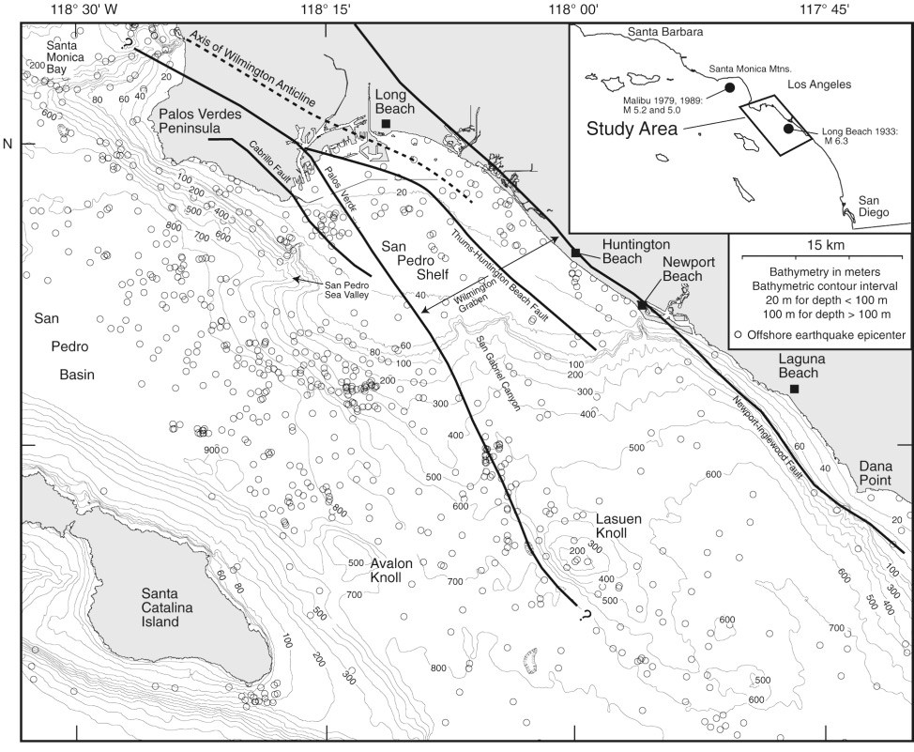

- What are the two plates affecting Southern California?

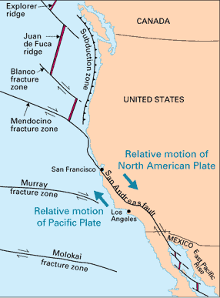
- What is the major fault line affecting Southern California? Why type of fault is it?

- As a result of plate movement, in which direction (north or south) is Los Angeles moving?

- How many different smaller faults affect the Palos Verdes area?

- Using the map to the left, what evidence do you see showing a lot of geologic activity in the Palos Verdes area?

Landslides Name:

A landslide is a movement of a mass of rock, earth or debris down a slope due to gravity.

Landslides belong to a group of geological processes referred to as MASS MOVEMENT: mass movement involves the outward or downward movement of a mass of slope forming material, under the influence of gravity.

Landslides are different from other forms of mass movement because they have 1) distinct boundaries and 2) rates of movement faster than any movement experienced on nearby slopes.

Landslide deposits can look like dislodged rocks to cracks in the ground.

Landslide movement may be instantaneous, with failure, transport and deposition taking place in a matter of seconds or minutes. Other landslides are known to have been intermittently active over tens of thousands of years, undergoing successive periods of reactivation.

Landslides can be: “active” (currently moving),“dormant” (no movement in the last twelve months but capable of being reactivated),“relict” (unlikely to be reactivated under present climatic or geomorphologial conditions).

What type of evidence can you find to show that a landslide is occurring?

Is this landslide active, dormant, or relict?

How can you distinguish this type of geologic movement from others?

(Palos Verdes Peninsula Land Conservancy, for more information visit www.pvplc.org)

Name___________________

Find the Fissure!

Use the map below to mark with a star the evidence that you find of a fissure. Then, below, describe in a sentence what the evidence is.
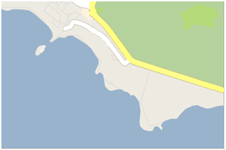

(Palos Verdes Peninsula Land Conservancy, for more information visit www.pvplc.org)

Volcanologists often search the landscape for evidence of fissures. These are cracks or openings in the Earth’s crust which allow the molten magma beneath to ooze up through the surface. This happens when an area of land gets stretched too far and cracks open.

Survey the surrounding area for geologic formations that appear much darker than the surrounding rock and on the map circle and write a sentence about where you see the fissure.

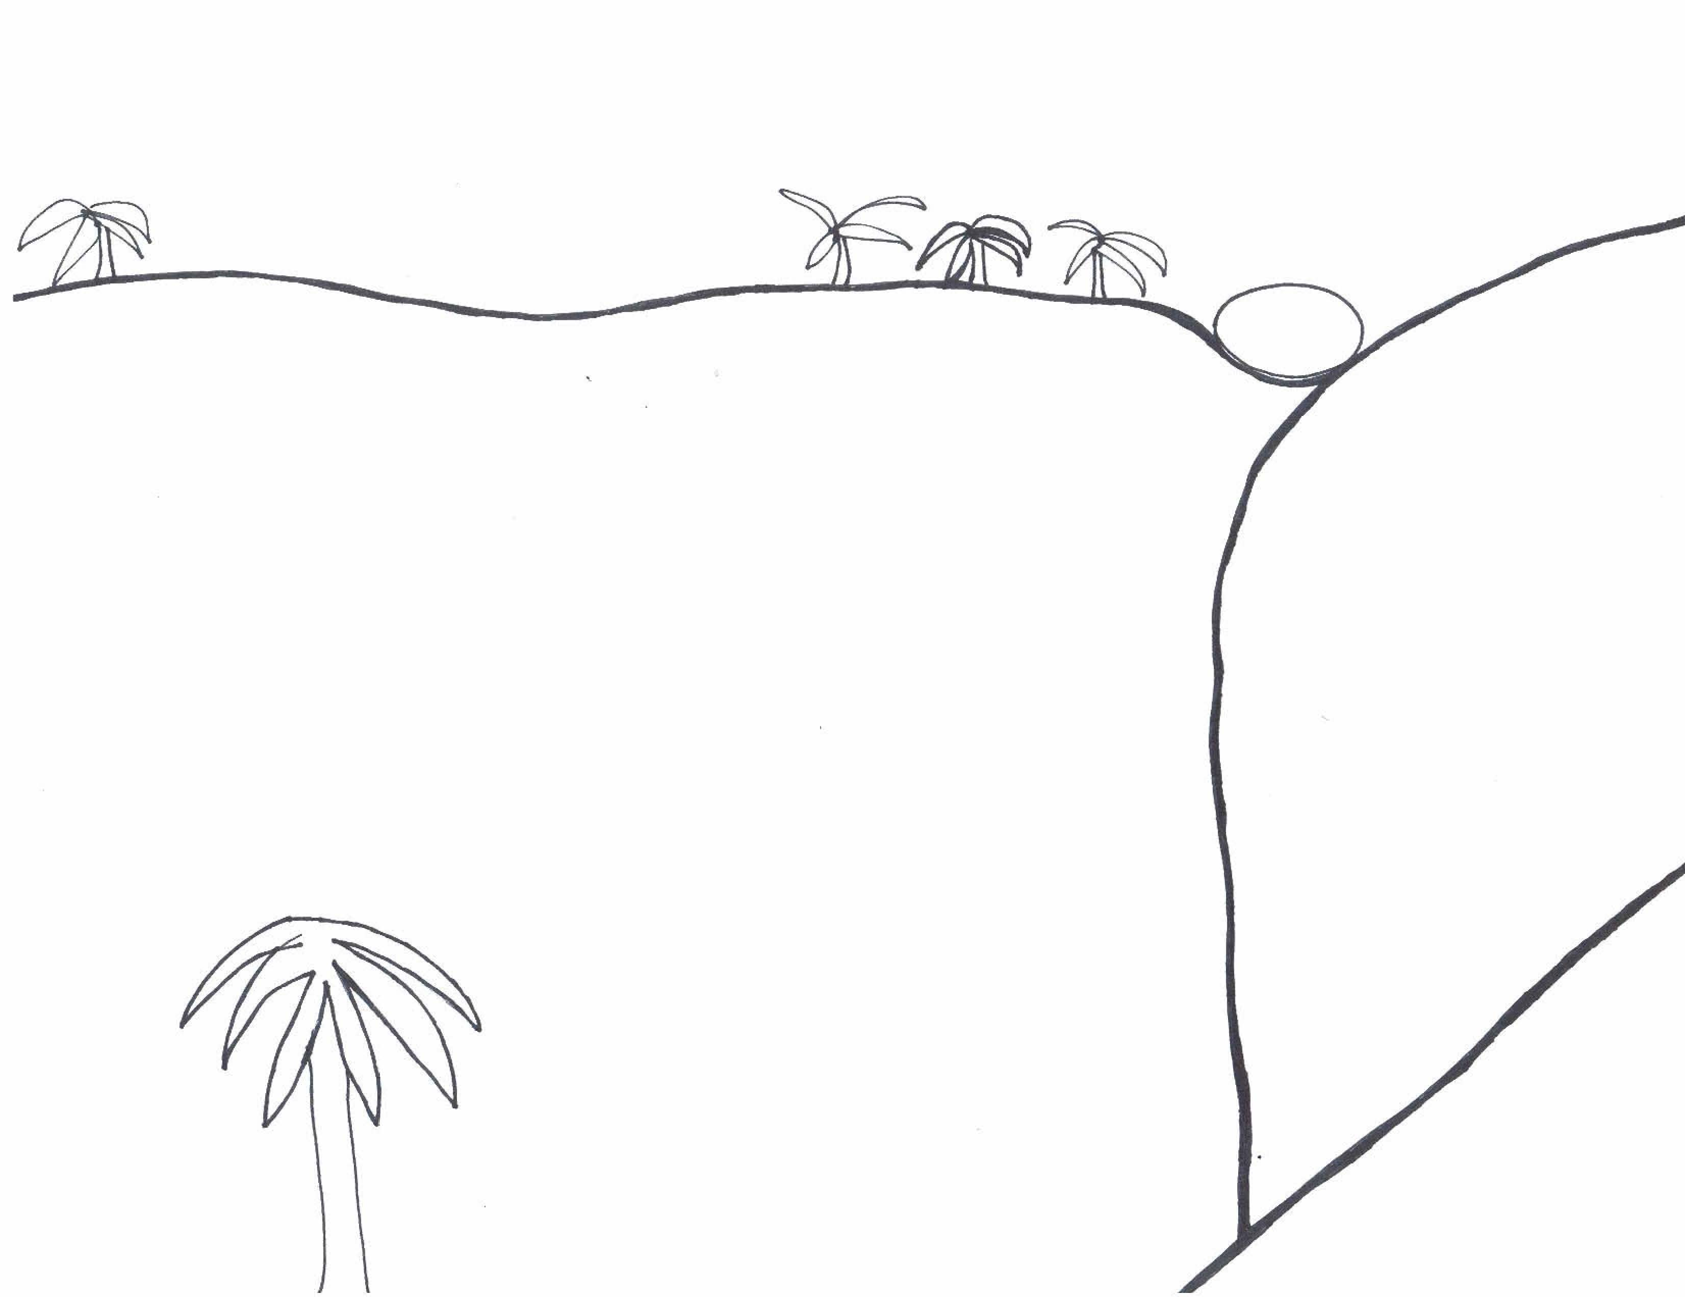
Name:_______________
Royal Palms State Beach

A recumbent fold occurs when geologic compression forces cause the center of a fold to go from being vertical to being horizontal. A talus slope is a slope of broken rocks formed from erosion, landslide, or rockfall. Draw and label the recumbent fold and talus slope in the diagram above.

(Palos Verdes Peninsula Land Conservancy, for more information visit www.pvplc.org)
Southern California Geology Summary

Use your knowledge from the lesson before the field trip and the field trip to Palos Verdes to answer the questions below.

- Why is there so much geologic activity and land movement in Southern California? What geologic activity and land movement are found in Palos Verdes?

- Some people say that Southern California might become an island. How would you respond to that statement? Explain your response in geologic terms. Do you think that will happen in your lifetime?

- Describe three pieces of evidence that you found in the field to show that there was geologic movement in the area:

a)

b)

c)

ICO Science Outdoors- 7th grade
Author: Becky Niemiec

Location:
The location of most of these outdoor field trips will be in Griffith Park, which is mainly dominated by a Coastal sage scrub community, one of the most threatened habitat types in the United States. The coastal sage scrub supports significant numbers of endemic species (found nowhere else). The scrub community consists of spiky yucca plants, cholla, and other rare native scrub that persists on sandy soils. Insect and reptile species, such as the Western Fence Lizard or the California Legless Lizard, are the most commonly seen and the most diverse. Griffith Park also contains Oak Woodland, which has one of the highest wildlife species richness of any habitat in California. The Oak trees provide acorns, which in turn provide food resources for many animals, such as the western gray squirrel and woodpeckers. Amphibians, such as the Coast Range newt, are also common in the area.

Science Standards: Below are specific science standards, taken directly from “Science Content Standards for California Public Schools,” that must be completed by the termination of 7th grade. These are the specific standards that would apply directly to the outdoor project.
-Biological evolution accounts for the diversity of species developed through gradual processes over many generations.
-students know both genetic variation and environmental factors are causes of evolution and diversity of organisms
-students know the reasoning used by Charles Darwin in reaching his conclusion that natural selection is the mechanism of evolution

Supplies: Plant identification books (2 are available from ICO- ask volunteers to donate others), zipblock bags to take plant samples, measuring tapes

Project: The 7th graders will participate in a 3 day research project- one day of which will be in the field- to become an expert on a particular plant and adaptations of that plant.

Day 1: In the classroom, students will be taught about basic plant adaptations and some of the plant species that they may see out in the field to gain an understanding of the types of adaptations that they might want to look out for. Students will be given the first worksheet below and discuss those adaptations. Students will also briefly be taught about the coastal sage scrub community, the Mediterranean climate of Southern California, and the frequent forest fires in the area.
Ask students about how an understanding of the environment of a plant can help give clues about the adaptations of plants and brainstorm questions about the environment around the plant. Bring in 5-10 different plants to the classroom and have students complete the worksheet below, recording their observations and the possible adaptations the plants might have based on those observations.
Day 2: Have students complete Plant Adaptations field study worksheet on the hike.
Day 3: Have students research online to complete the final worksheet and synthesize their observational studies with their online research. Have students give a brief three minute presentation on their plant to the rest of their class.

Plant Adaptations

The flora of an area are the plants of that region. Scientists record facts about the flora of a region to understand more about the ecology of the area, while others keep track of flora to understand which plants can be used for agriculture or medicine. The flora of different habitats are different from one another because many plants have adaptations to their specific environment. Adaptations are traits that help an organism survive better in certain conditions.

If you were a plant…
What sort of adaptation would you want to prevent animals from eating you?

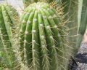
Spines! The needles on a cholla plant or barrel cactus, such as the one to the right, protect the plant from being eaten by thirsty animals in the desert looking for a source of water.
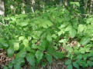
To Toxins! Poison oak and poison ivy have toxins that are released when another organism brushes up against the plant. This is an adaptation to prevent animals from feeding on the leaves or to prevent hikers like you from trampling the plant! Beware of poison oak in the field… it has leaves of three.

What sort of adaptation would you want to prevent water loss if you were living in a very dry area?
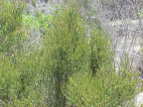
Small, tiny Leaves! Chamise, a plant that is part of the Chaparral community, has tiny, clustered leaves with less surface area that prevent it from losing water in the dry climate of Southern California.
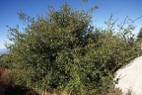
Wax-coated Leaves. The California scrub-oak has a waxy coat over its leaves, which helps prevent water from evaporating in the heat.
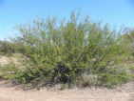

Deep Roots! Some plants, such as mesquite, shown on the right, have very deep and extensive root systems so that they can reach hard to get water in the soil.

Name:___________________________

Plant #: | Observations of Plant Structures (leaves, height, flowers, seedpods, etc) : | Potential Adaptations of Plant based on Observations:

Name:
Partner:
Plant Adaptations Field Study

In the field, you will conduct an observational study with a partner on one particular plant species that you see out in the field. You can choose any tagged plant, from a Sycamore Tree to white sage or a cholla cactus. Use the plant guides provided to identify your plant. You will complete an environmental observational study and then a study of the leaves of the plant. Answer all questions below.

Name of plant_______________________________________

- Environmental Observations:

- Describe the texture and color of the soil around the plant as well as the size of soil and rock pieces.

- Are there other plants growing within a meter radius of the plant? What types?

- Is the plant in a canyon or on an exposed hillside? Is it in the shade or sun?

- Plant Characteristic Observations:

- How tall is the plant? What is its circumference? Use measuring tape provided.

Height_________________ cm. Circumference____________cm.

- What types of leaves does the plant have? Are the leaves small, large, waxy, clustered, dark green, or light? Use the magnifying cubes to take a closer look at the leaves. List 4 properties of the leaves and draw a picture below of the leaves.
Properties Picture
1.
2.
3.
4.

- Were any flowers evident on your plant? Describe them. Were any fruit or seedpods present? Describe. How do you think your plant disperses seeds?

Name:
Partner:
Plant Adaptations Research and Synthesis

Research online and in books available to find out more information about your plant that you could not find out on your own in the field and answer the research questions below. You will then synthesize these research findings with your field observations to write up your final report on your plant adaptations.

Name of plant________________________________________________

- Research Questions:

- Describe the climate that the plant lives in. What is the average annual precipitation? Does the plant suffer from fire or droughts?

- Is the plant endemic to Southern California, or does it live in other places, too? Is it endangered or common?

- What types of animals prey upon the plant? Does it have any defensive adaptations?

- Describe an adaptation that the plant has to the climate and environment it lives in. This adaptation might have to do with properties of its leaves, its height, or its means of reproduction.

- Synthesis: Choose two different observations, either of the environment or the plant itself that you found in the field. How do these observations provide evidence for the adaptations that the plant has that you found in your research?

1)

2)
ICO Science Outdoors- 8th grade
Author: Becky Niemiec

Location: The 8th grade trip will be to Malibu Creek State Park, which has 15 miles of streamside trail through oak and sycamore covered slopes. The trip can also be to Millard Canyon in Altadena, which is a closer location to most schools, and has hikes along a stream.

Science Standards: Below are specific science standards, taken directly from “Science Content Standards for California Public Schools,” that must be completed by the termination of 8th grade. These are the specific standards that would apply directly to the outdoor project.
-students know that average speed is the total distance traveled divided by the total time elapsed and that the speed of an object along the path traveled can vary.
-students know how to interpret graphs of position versus time and graphs of speed versus time for motion in a single direction
Reactions
-students know how to determine whether a solution is acidic, basic, or neutral.
Investigation
-Recognize the slope of the linear graph as the constant in the relationship y=kx and apply this principle in interpreting graphs constructed from data.
-Apply simple mathematic relationships to determine a missing quantity in a mathematic expression, given the two remaining terms (including speed=distance/time, density=mass/volume, volume=areaxtime)

Supplies: stop watches (optional), pH paper, dissolved oxygen meter (optional) have students bring calculators, measuring tape, ping pong balls as floats, thermometers

Projects:

- Students will complete a worksheet and study (see below) to relate their mathematical skills to science and natural systems by calculating how fast the stream is moving.
- Students will then take the pH of the stream and discuss the water quality by comparing the pH that they got with the table provided in the ____________________
- For the second stream trip, students will get into groups and run an experiment looking at how stream velocity affects different aspects of water quality. The most important tests typically used for testing water quality are pH, temperature, conductivity, microbiological quality, dissolved oxygen, and turbidity. I can come into labs before the field trip and help students get into “expert groups” of 3-5 and learn how to use the equipment needed for their project. Expert groups can be focused on pH, turbidity, temperature, or dissolved oxygen. Students should develop a hypothesis in groups about how surface velocity and a specific aspect of water quality are related(e.g. The faster the surface velocity of the stream, the higher the dissolved oxygen OR the surface velocity does not change the temperature). See “Water Quality Assessment” below.
How Fast is the River?

In order to find out how fast a river is traveling, scientists sometimes use floats to get distance and time measurements. Floats are small objects that are brightly colored so that they can be seen and must not be tall, so only the water, not the wind carries them. Find a float around you that fits the criteria and follow the directions below to find out the speed of the river. Do this project with a partner.

Step 1: You and your partner will measure out a length along the stream that is relatively straight and that you can see easily. This length should be between 5-10m and there should be a recognizable marker in the stream or on the side of the stream where you can tell exactly where your distance ends.
Record your distance here:____________ meters

Step 2: One of your partners will be the designated “time keeper” while the other is the “float dropper.” The time keeper should keep track of the exact time it takes for the float to travel the exact distance that you set out once it is dropped by the float dropper. The time keeper can use a watch or careful counting.

Step 3: Both partners should record the time it took for your float to travel your exact distance. Then repeat Step 2 two more times to get a total of three trials in the box below. You may need to get a new float every time.

Trial  # | Time
Step 4: Calculate the average time it took for the float to travel based on the three trials.

Average time:__________________________

Step 5: Use the distance/average time to find the surface velocity of the water. Why is this a velocity, not a speed?

Surface Velocity:__________________m/s______

Water Quality Assessment

Another measurement that you can do as scientists to learn more about a stream is to do as a water quality assessment. Get into groups of 3-5 and choose a measurement of water quality: temperature, Dissolved Oxygen, pH, and turbidity. Follow the steps below to complete your study.

- The surface velocity of the stream that you just calculated changes in different areas of the stream. How do you think different surface velocities will change your specific measurement of water quality? Complete the hypothesis below:
I hypothesize that _____________stream velocity will __________________.
Increased/decreased decrease/increase/not effect temp, pH, etc

- Collect data. In order to calculate stream velocity, see the “How Fast is the River?” sheet. For these measurements, you do not have to take three trials, just one. You will pick three different locations along the stream, measure velocity, and then measure your aspect of water quality. Fill out the table below (including the top right corner with your specific measurement):

Location  # | Time | Surface  Velocity

- Draw a graph below with your results, with surface velocity on the x axis and your specific stream quality measurement on the y axis. Is the graph linear or nonlinear?

4. Do your results support your hypothesis? Why or
why not?

How Healthy is the Stream?

Table 5. Effects of pH on fish and aquatic life
pH value |  | Effects observed under research
Min | Max
3.8 | 10.0 | Fish eggs could be hatched, but deformed young were often produced.
4.0 | 10.1 | Limits for the most resistant fish species.
4.1 | 9.5 | Range tolerated by trout.
4.3 | -- | Carp died in five days.
4.5 | 9.0 | Trout eggs and larvae develop normally.
4.6 | 9.5 | Limits for perch.
5.0 | -- | Limits for stickleback fish.
5.0 | 9.0 | Tolerable range for most fish.
-- | 8.7 | Upper limit for good fishing waters.
5.4 | 11.4 | Fish avoided waters beyond these limits.
6.0 | 7.2 | Optimum (best) range for fish eggs.
1.0 | -- | Mosquito larvae were destroyed at this pH value.
3.3 | 4.7 | Mosquito larva lived within this range.
7.5 | 8.4 | Best range for the growth of algae.
References 2

Measure the pH of the stream in three different locations. What is the average pH of the stream? __________ How might that affect aquatic life based on the chart above? Give 3 examples. Is this a healthy stream?

